**Detach an EBS Volume**

* + **Selecting the EBS volume you want to detach**
  + Choose the bucket

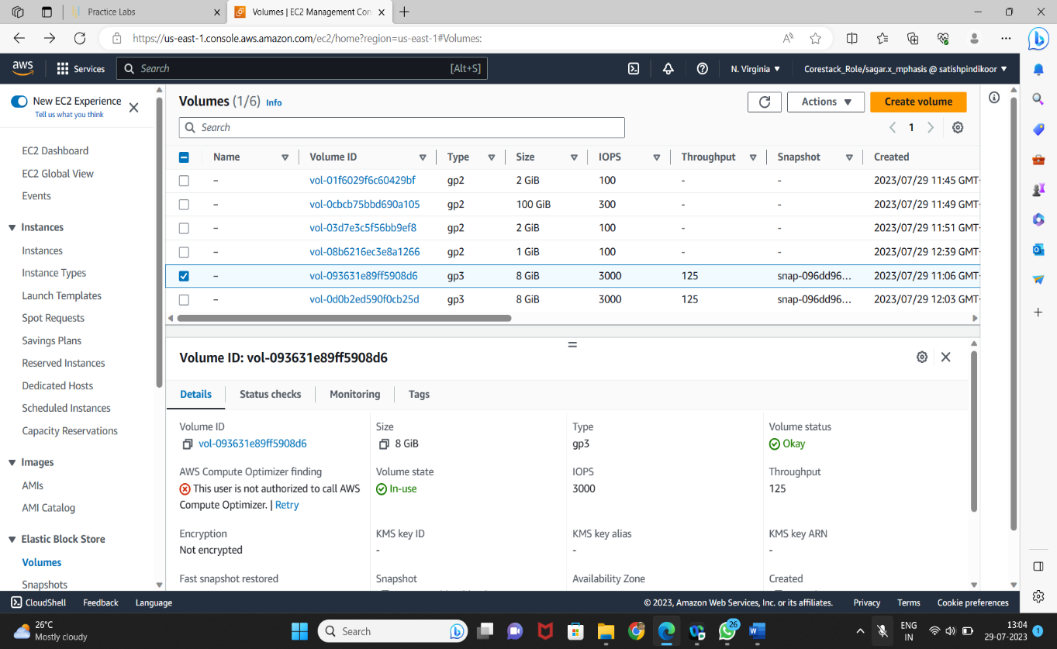

* Select *Detach Volume* option

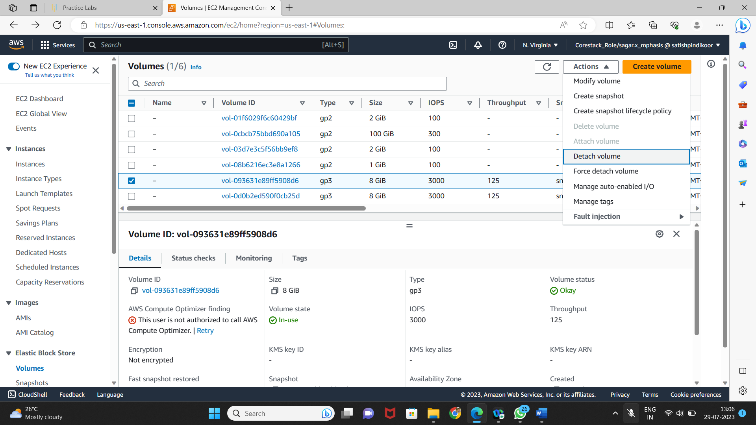

* **Detaching the volume**
* Select *Yes* once the confirmation pop-up appears

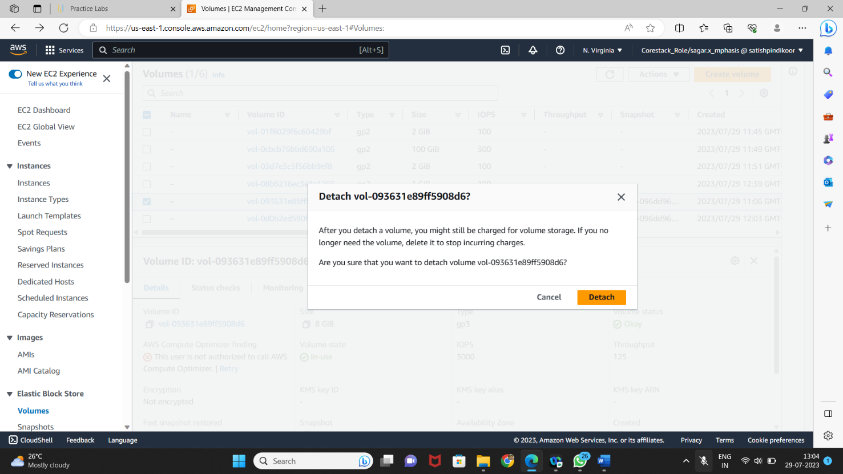

* Once detached, the volume will be labeled as *Available*

